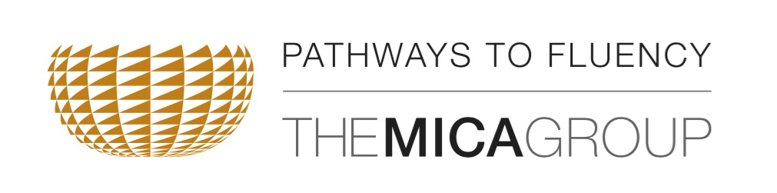
Pathways to Fluency: Cultural Survival Through Language Revitalization
Cultural Resource Fund Scholarship Application Form
Due September 30, 2016
Please complete this form to be considered for financial assistance for the CRF Language Gathering. The Gathering will be held at the Isleta Resort & Casino, 11000 Broadway, SE Albuquerque, NM 87105, on December 12-15, 2016.
The CRF Language Gathering will bring together national and international visionaries on Native language revitalization. It will be followed, in early 2017 by awards totaling more than $2 million to fund Tribal language revitalization projects. Tribes and Tribal Nations interested in applying for Phase 3 language grants are strongly encouraged to send a representative. The ideal attendee would be the Tribal Language Director.
Applicants must represent a CRF-eligible Tribe. A list of eligible Tribes and Tribal Nations can be found at www.culturalresourcefund.org.
Scholarship applicants agree to attend and participate in the entire Language Gathering beginning with an evening reception on Monday, December 12, and ending on Thursday, December 15 at noon.

The maximum value of the scholarship is $650. Scholarships may be used for airfare and three nights lodging (at $89/night). Meals during the Gathering will be provided at no expense to scholarship recipients. Per diem is not available. Scholarships may be spilt among several people, but only one scholarship will be awarded per Tribe or Tribal Nation.

Scholarship applicants may not register for the event until they have received a decision on their scholarship request.

Scholarships are limited and based on:
- Financial Need
- Tribe or Tribal Nation’s readiness to begin language revitalization activities

Name

Title

Tribe

Department

Cell Phone Office Phone

E-Mail

Why are you requesting a Scholarship?

Please describe your Tribe’s current language revitalization activities and describe your role.

Please describe your Tribe, Tribal Nation, Community or Language Department’s vision for language revitalization.

Please email questions and completed forms to culture@micagroup.org, or mail to Peggy Mainor, 5301 Springlake Way, Baltimore, MD 21212.

Applications must be received by September 30, 2016. Awards are limited and will be made on a rolling basis. Please submit your application as early as possible.

